**B.1.** **Can you tell me No of Vehicles by Brand Available on ebay for sale with the help of visualization.**

To find the total count of vehicles by type I used groupby() function. From that group by data I have created a new data frame named da.

And then I plot a bar plot on that.

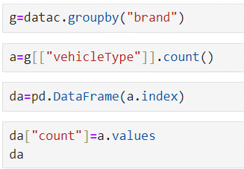

And the new data looks like this:

By using the below code I’ll show the visualization of me no.of vehicles by brand available on ebay for sale.

From the above plot I can tell that Volkswagen brand has more number of vehicle available on ebay for sale and the count is 79640.

And the brand lada have less number of vehicles available on ebay for sale with the count of 225.

**B.2. What is the Average price for vehicles based on the type of vehicle as well as on the type of gearbox.**

**#Explain me with both numerical and visualization analysis**

a.For average price for vehicles based on vehicle type.

To find the average price for vehicles by type I used groupby() function. From that group by data I have created a new data frame named data_vehicles.

And then I plot a bar plot on that.

From the above plot the average price for vehicles based on vehicle type is high for andere with the 677329.

And kleinwagen ha less price with 5695.

b.For average price for vehicles based on gearbox type.

To find the average price for vehicles by gearbox type I used groupby() function. From that group by data I have created a new data frame named data_gearbox.

By using below code I created a new data frame.

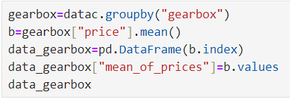

from the below code I created a bar plot for average price of vehicles based on gearbox type.

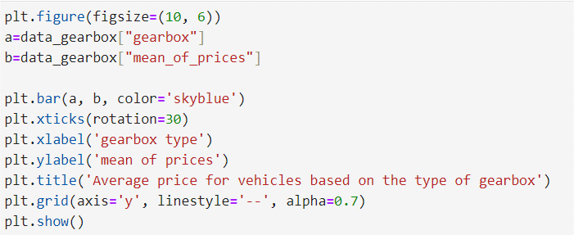

from the above plot I can tell that the vehicles which don’t have any type has more average price when compared to others with 44019.

And automatic has less average price with 15146.

**B.3.What is the marginal probability of private seller.**

From that the marginal probability of private seller is 0.99.